


I
II
III
IV
V
VI
VII
The Millennial, Gen X
& Boomer Dilemma




Content Overview

I. Introduction……………………………………………………………………………………………………………………2
II. Generations Defined………………………………………………………………………………………………………2
III. Contradictory Value Systems………………………………………………………………………………………….3
IV. Capitalization on Generalizations……………………………………………………………………………………3
V. Screening for Success……………………………………………………………………………………………………..4
VI. Engaging Millennials.……………………………………………………………………………………………………..4
VII. Conclusion
PART 1

Generational Philosophies

I. Introduction:
Main Questions:
The Windmill: Off-Balance
Permission: The Honest Truth
Generalizations: The Crucial Importance “generalization, which is an act of reasoning that involves drawing broad inferences from particular observations, is widely-acknowledged as a quality standard in quantitative research” (Beck & Polit, 2010).

II. Generations Defined:
Descriptions:
Write down the first three words that come to your mind when you think about:

- Baby Boomers: Ages today: 73-55¹: 1. ___________, 2. ___________, 3. ____________.
- Generation X: Ages today: 54-39¹: 1. ___________, 2. ____________, 3. ____________.
- Millennials: Ages today: 38-19¹: 1. ____________, 2. ____________, 3. ___________.
“For the first time in history, four generations are working side by side. Different values, experiences, styles, and activities create misunderstandings and frustrations” ².

Millennial:
Frustration: Just because I’m younger than 38 doesn’t mean I’m not committed!
Lack of Experience: I know a lot! Why isn’t everyone asking me for my opinion?
Learning Style: Google: How ___________ can I find the information?

Gen X:
Frustration: Just because I’m in the middle doesn’t mean I can’t offer wisdom to both generations!
Enough Experience: I know what I’m good at and what I’m not. Has this impacted my cash flow?
Learning Style: Pragmatism: Does it ___________?

Boomer:
Frustration: Just because I’m older than 55 doesn’t mean I’m not creative or productive!
Too Much Experience: I’ve been in this world for way too long not to know what I’m doing!
Learning Style: Experience: How many ___________ have you learned your lessons?

Footnotes: ¹Ages (Based on Generational Differences Chart: Boomers: 1946-1964, Gen X: 1965-1980, Millennials: 1981-2000). www.wmfc.org/uploads/GenerationalDifferencesChart.pdf
²http://www.aea10.k12.ia.us/leadership/ldrshipdev.html

I
II
III
IV
V
VI
VII

PART 1

Generational Philosophies

III. Contradictory Value Systems:
Conflict:
How the value systems of Boomers directly contradict the value systems of Gen X and Millennials: __________ & __________ IP at all costs to full disclosure and ____________________.
The greatest fear of every generation and how it causes inherent conflict in the workplace: What will I lose?
B: Do I have to give up my experience? G: Do I have to give up my savings? M: Do I have to give up my free time?

- Values: What is important to you?
- Motivation: What you think and feel about your day?
- Incentives: What you think and feel about your quarter and yearly goals?
- Expectations: What are your positive and negative beliefs about others?
- Interactions: What is your normative response when others agree and disagree with you?
- Strengths: What enhances your impact in the organization?
- Weaknesses: What you don’t know can hinder your influence in the organization?

IV. Capitalization on Generalizations:
Statistics:
“Boomers will continue to be the wealthiest generation in the United States until at least 2030 (figure 2). Their share of net household wealth will peak at 50.2 percent by 2020. Generation X will experience the highest increase in share of national wealth through the forecast period, growing from under 14 percent of total net wealth in 2015 to nearly 31 percent by 2030. The generation’s (Millennials) share of national household wealth will remain below 20 percent” ³.
(Pre-Boomer Era: “The Silent Generation” reports on the remaining 16 percent wealth ownership).

Main Question: Does your business plan, marketing strategy and revenue reflect these truths?
Meaning: Does your product/service focus 66% upon those individuals that are 55 and above and 34% below 54 years old?
Solution: Have you have developed a unique model (Generalization Model for Revenue Growth), that is age targeted or for the general public, that is more inexpensive or to corporate companies? If not, you will struggle with cash flow if you gear your focus toward those 54 and below.

Deeper Question: How much money are entrepreneurs making today and doesn’t this explain the struggle today?

Footnotes: ³(Val Srinivas, Urval Goradia, November 09, 2015).

https://dupress.deloitte.com/dup-us-en/industry/investment-management/us-
generational-wealth-trends.html

I
II
III
IV
V
VI
VII

PART 1

Generational Philosophies

V. screening for success:
Filtration:
The purpose of a filter, regardless of function for oil, water or air, is to protect by limiting harmful elements that could decrease the effectiveness of the machine or individual.

Main Question: You filter the oil in your vehicle, purchase filtered bottled water and every 90-days replace the filter in your HVAC, when was the last time you looked at your organizational filter?

Answer: The length of time you can retain a follower (employee) or a client (customer) reveals the quality of your organizational filter. It could be accidental but excellent companies build their follower and client filters from scratch and have regular check up meeting to ensure the level of productivity has not decreased.

Solution: Have you developed specific interview questions questions (Organizational Screening Tool) to determine the right hire and correct client for your organization, regardless of demographic?

VI. Engaging millennials:
Secrets:
“58% of its largely millennial user base said they plan to change jobs this year. What they are searching for is learning and growth opportunities, as well as work-life balance, Muse co-founder and CEO Kathryn Minshew told CNBC” (https://www.cnbc.com/2019/04/08/58percent-of-millennials-plan-to-change-jobs-for-more-learning-opportunities.html).

What are the 3 main secrets that you must know in order to fascinate, equip and retain millennials as followers or customers:

- _______________,
- _______________,
- _______________.

Solution: Do you have your Boomer, Gen X and Millennial Recruitment and Retaining Strategy developed and implemented?

Notes:

I
II
III
IV
V
VI
VII

PART 1

Generational Philosophies
CALCULATION

VII. Conclusion:
Secrets:
While The Generational Paradox Discussion on: Part 1: focused upon Generational Philosophies, Part 2: will target Generational Planning which will assist you in creating the following solutions:

∞ Generalization Model for Revenue Growth,
∞ Organizational Screening Tool,
∞ Multi-Generational Recruitment and Retaining Strategy.

Here at The Global Equipping Centre, our team is passionate about meeting with business individuals who enjoy their company and have a passion for their products and services. If you would like to set up a one-on-one appointment please email us: email@thegecsa.com

We look forward to seeing you again for Part 2!

Links for further research:

http://genhq.com/faq-info-about-generations/

http://www.pewresearch.org/fact-tank/2016/04/25/millennials-overtake-baby-boomers/

https://en.wikipedia.org/wiki/Generation

http://www.theatlantic.com/national/archive/2014/03/here-is-when-each-generation-begins-and-ends-according-to-facts/359589/

https://www.careerplanner.com/Career-Articles/Generations.cfm

http://hr-gazette.com/coaching-millennials/

https://www.youtube.com/watch?v=zY1raLxyaKM

Amazing Video, Researched speaker: First 15 minutes: https://www.youtube.com/watch?v=OPaQPWfqjmw

I
II
III
IV
V
VI
VII

PART 1

Generational Philosophies
CALCULATION

The Global Equipping Centre:

Our Services & Opportunities:
The Global Equipping Centre (GEC) is an exponential growth catalyst for businesses and non-profit organizations seeking executive coaching, organizational consulting, innovative training seminars, and/or motivational speaking.

Our Executive Coaching Team consists of highly experienced professionals, all who specialize in unique areas of concentration, according to their background and professional training.

If you fit the criteria of any of the following you may want to meet with one of our team members:
∞ Creating new ideas as a business owner or entrepreneur,
∞ Working in a corporation or non-profit,
∞ Launching a new business, project, division, branch, product or service,
∞ Looking for an increase in personal and/or professional revenue or donations,
∞ Needing to create business infrastructure,
∞ Improving a social media strategy with a unique, online, sales campaign,
∞ Developing a succession plan (retirement strategy) to leave a lasting legacy.

Please contact us at: email@thegecsa.com for an appointment today!

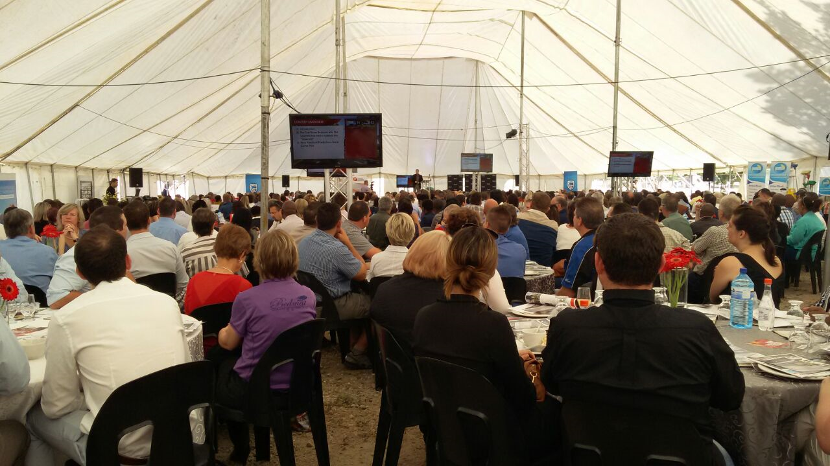

I
II
III
IV
V
VI
VII

PART 1

Generational philosophies

VII. Conclusion:

Violate or Validate: Removing the Guesswork From Interpersonal Relationships.

“75.4 million U.S. millennials in 2016; Will peak at 81.1 million in 2036; $300 billion annual spending; Will be 50% of workforce by 2020” ⁶.

As of today, in 2017, there is a high possibility that you currently have a Boomer, Gen Xer and Millennial working with you in your company today. While all four of the DISC personalities remain the same regardless of birthyear, understanding each cohort will increase your team’s unity, individual happiness, and corporate productivity.

Notes:

Footnotes ⁶(Derrick Feldmann, November 2016).
www.casefoundation.org/wp-
content/uploads/2016/11/FiveYearRecap_MIR_1123161.pdf

I
II
III
IV
V
VI
VII

PART 1

Generational philosophies

Statistics:

Did you know, compared to Boomers and Gen Xers, Millennials move less, buy fewer homes, marry older and have fewer children than their older counterparts (Richard Fry, February 13, 2017)? http://www.pewresearch.org/fact-tank/2017/02/13/americans-are-moving-at-historically-low-rates-in-part-because-millennials-are-staying-put/

“32% of millennials considered themselves entrepreneurs, compared to 41% of Generation X and 45% of baby boomers. Additional research from EY and the Economic Innovation Group discovered that 44% of millennials believe staying with one company is best for their career, compared to only 22% who want to start a business” (Dan Schawbel, Feb 12, 2017). https://fortune.com/2017/02/12/millennials-entrepreneurs-student-debt-self-employed/

35% (Gen Xers) have college degrees vs. 19% of Millennials (Anna Sofia Martin, September 13, 2016). http://www.forbes.com/sites/nextavenue/2016/09/13/the-undetected-influence-of-generation-x/#3bf9e17f36ab

I
II
III
IV
V
VI
VII

PART 1

Generational philosophies

Statistics:

“Xers carry more personal debt than did any other generation at their age in our nation's history” (Ted Halstead, August, 1999). https://www.theatlantic.com/magazine/archive/1999/08/a-politics-for-generation-x/306666/

“The baby boomers built an economy where young people increasingly need a college education to move into the middle class, or even to simply hold on to the middle-class lifestyle they were born into” (Jim Tankersley, October 5, 2012). https://www.theatlantic.com/business/archive/2012/10/who-destroyed-the-economy-the-case-against-the-baby-boomers/263291/

“One major difference between these generations? Millennials want to be special” (Mallory Schlossberg, June 20, 2016). http://www.businessinsider.com/differences-between-boomers-gen-x-and-millennials-2016-6

“Monetary giving will grow to a cumulative $6.6 trillion over the next two decades, according to ‘Giving in Retirement: America’s Longevity Bonus’” (Karen Demasters, October 22, 2015). http://www.fa-mag.com/news/boomers-boost-charity-dramatically-23584.html

Notes:

VI. Biased or Prejudiced:

Biased: noun
2. “unreasonably hostile feelings or opinions about a social group” ⁴

Prejudice: noun
1. “an unfavorable opinion or feeling formed beforehand or without knowledge, thought, or reason.”
2. “any preconceived opinion or feeling, either favorable or unfavorable” ⁴

“What is Prejudice? A judgment formed by an individual who is based on thoughts that are premature and are not based on thorough study or research about a group of people or individuals.”

“What is Bias? Bias is a term usually referring to comparisons between people or groups of people that is not just. Bias can also be referred to as a natural inclination to an opinion or thought that someone holds about something.”

“Bias refers to a thought of an individual or a group which is leaning towards an area of life such as politics, society, religion or economics. Prejudice is the process of making decisions or judging something with a premature mind and making your own facts instead of knowing the real truth about a person or a thing. Bias can be referred to as a process where you prefer one thing over another thing. Prejudice is the word used to refer to something that you hate completely.”

“In simple words, bias is a positive or negative opinion that one might have. This opinion is mostly based on the experience of a person. However, prejudice is something unnatural in which you completely avoid or hate one thing or are addicted to something and love it without any specific reason.” ⁵

BIAS | PREJUDICE
A thought | A process
A preference over one area | A hatred regarding any area
An experience based in reality | An experience created in the mind
A comparison | A decision

Footnotes: ⁴www.dictionary.com
⁵http://www.differencebetween.com/difference-between-prejudice-and-vs-bias/

⁵http://www.differencebetween.com/difference-between-prejudice-and-vs-bias/

I
II
III
IV
V
VI
VII

